COS225 Assg #4 Name: Nicholas Soucy

Part I. (20 pts.)

1. (6) Write a generic method peek2 that could be passed a stack of any type and returns the item that is one down from the top. If the stack does not have 2 items, the method returns the null reference. Note the method does not permanently alter the contents of stack; when the method is done the stack has the same state as before the method call.

public class TestPeek2 {
public static void main(String[ ] args) {
ArrayStack<Integer> istack= new ArrayStack <> ( );
ArrayStack<String> sstack= new ArrayStack <> ( );
ArrayStack<Double> dstack= new ArrayStack <> ( );

istack.push(10); istack.push(20);
sstack.push("red"); sstack.push("blue"); sstack.push("yellow");
dstack.push(1.5);

Integer i = peek2(istack);
if (i == null) System.out.println ("Integer stack does not contain at least 2 elements");
else System.out.println ("Integer stack second item is " + i);

String s = peek2(sstack);
if (s == null) System.out.println ("String stack does not contain at least 2 elements");
else System.out.println ("String stack second item is " + s);

Double d = peek2(dstack);
if (s == null) System.out.println ("Double stack does not contain at least 2 elements");
else System.out.println ("Double stack second item is " + d);
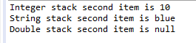
}

// write method peek2
public T peek2 ( T [ ] stack ) throws EmptyCollectionException { //POST: return 2nd element
if (isEmpty( )) //if stack is empty throw exception
throw new EmptyCollectionException ( );
else if (top <= 2 ) //if stack doesn’t have two or more elements, throw exception
throw new EmptyCollectionException ( );
else //if stack doe have two or more elements, return 2nd entry
return stack [ top-2 ];

2. (6) Using the ArrayStack class developed in lecture, list the output of each line.

ArrayStack<Integer> s = new ArrayStack<Integer> ( );
s.push (20); s.push (40); s.push (50);

System.out.println (s.size( )); 1
System.out.println (s.peek( )); 2

s.push (80); s.push (30); s.pop ( ); s.push (10);

while (!s.empty( ))
{ System.out.print (s.peek ( ) + " "); 3
s.pop ( );
}

- 3
- 50
- 10 80 50 40 20

3. (4) Using the LinkedStack code, draw a picture of the linked list below after a pop( ) method. Draw the nodes and values in the next field (arrow or null). Reference top should use an arrow to point to its node. If a node has been garbage-collected, do not include it in the picture.

top |  | 15 |  |  | 25 |  |  | 10 | null

Your picture:

top |  | 25 |  |  | 10 | null

4. (4) Using the ArrayQueue code and the original state shown below, draw a picture of the array after an enqueue of value 5. Show items in the queue and indicate the value in front and rear.

 | 25 | 10 | 30
0 1 2 3 4
front: 1 rear: 4

Your picture:

 | 25 | 10 | 30 | 5
0 1 2 3 4

front: _______1________ rear: _______0________

Part II: (80 pts)

Version 1: Console application

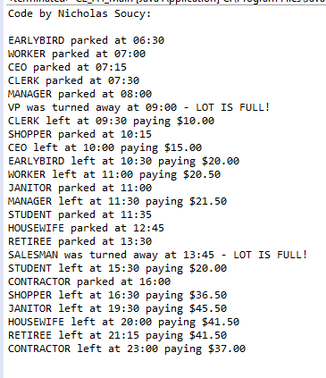
Version 2: Graphics application

Sample Arrival: Sample Reject:
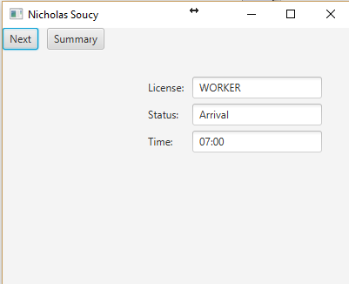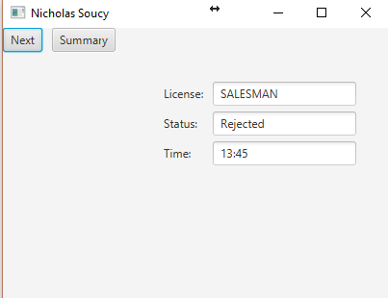
Sample Departure: Sample Summary:
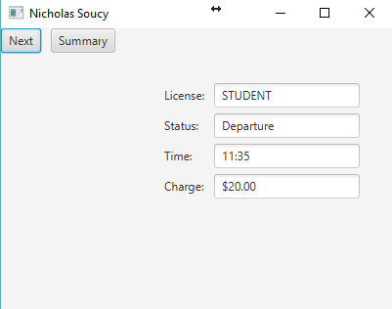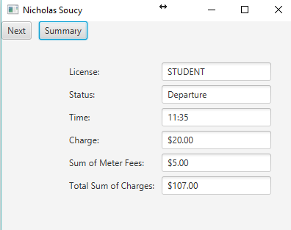

End of Simulation:
